**This document goes over on software download and installation**

**For Windows users (OSX coming soon)**

We have developed Asura software for all your need. You can follow this guide to download and use Asura

[**Asura user guide**](https://drive.google.com/open?id=1ujuHiMBNtAiURRonDJZQ4sKzHopYzQR3W7yzaehJ2Jc)

**For OSX users or users who needed advanced control of the slicing process**

* Download and Install Cura
* Download Meshmixer

After calibration, it is time to set up software.

Before you can print, you would need to install:

Meshmixer

You do not need to install any hardware driver

-

**Cura Installation**

**Please refer to this** [**Wiki document**](http://wiki.peopoly.net/doku.php?id=moai:cura&s%5B%5D=cura) **to install Cura and come back for other software installation.**

Once it is installed, make sure you have the latest profiles.

Yours should look like:

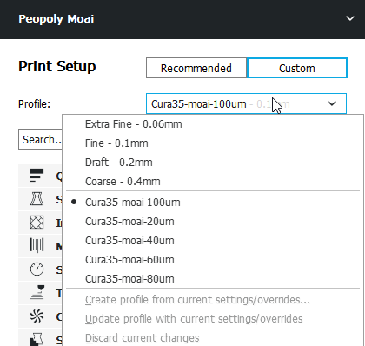

Where Cura35-moai profiles are listed. There should be five of them ranging from 100um to 20um. The 20/40/60/80/100 um are layer heights. They represent how thin each layer is and affects Z-axis resolution of the print. The most commonly used profiles are 100um and 40um. 100um for faster print and very good results while 40um gives a higher resolution print at a longer print time.

If you do not see the Cura35 profiles, please import them according to the wiki.

After you download the profiles, this is the screen that will give you the import function:

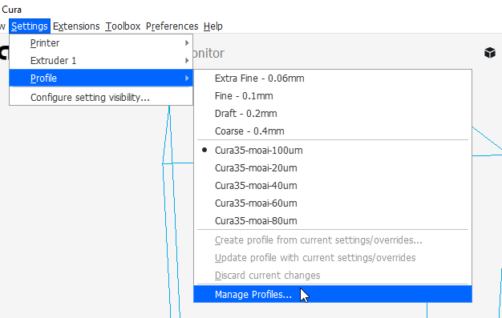

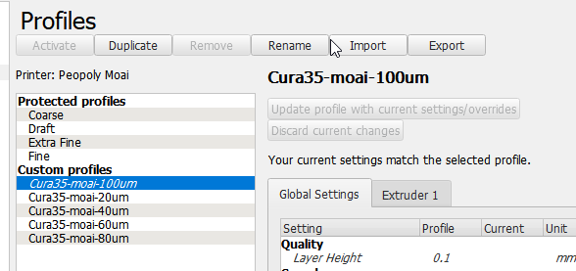

**4. Dry test (without resin)**

Resin can get messy so let’s check functions before we start printing.

You can test print the Moai stl file [here](https://drive.google.com/open?id=0Bzke6lBHG_z5NEFJYzdoVlZIU3M) using the settings.

* Load the stl file into Cura
* Move it to C spot indicated below on Cura platform

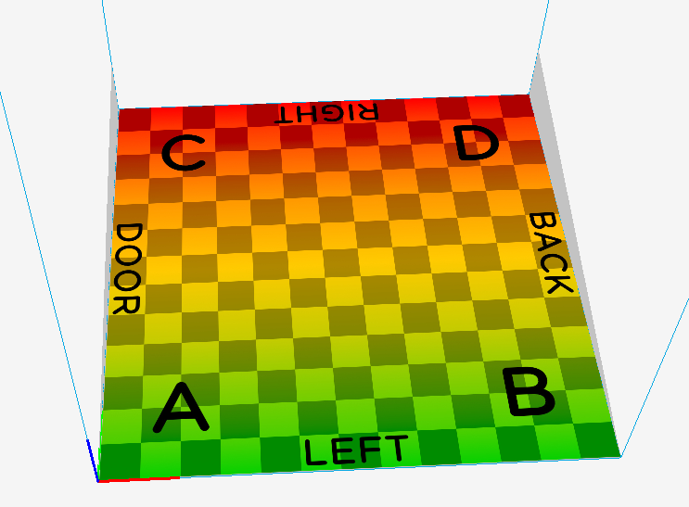

Like this

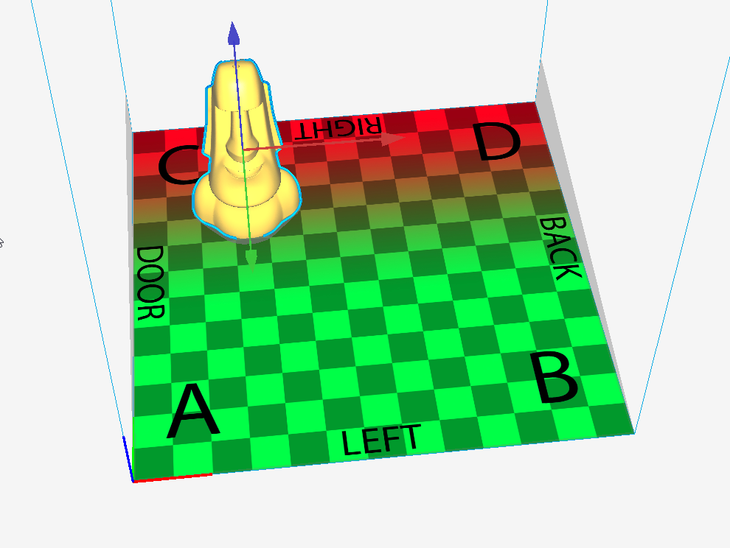

* Use Cura to slice the file,

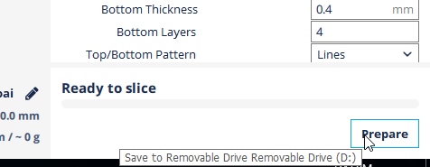

* save to SD card’s gcode directory and
* Put the SD to the printer and print from menu

As it goes to each layer,

Check the peel action at each layer and see if Z-axis is moving correctly. It should steadily move upward.

--

This is how Cura’s platform translates into vat position:

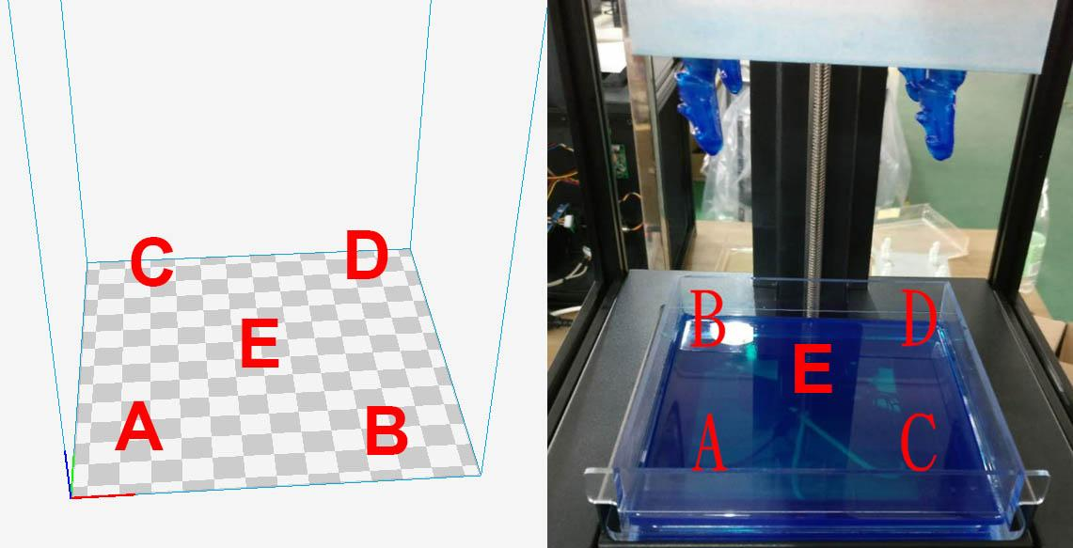

Action sequences should be:

Laser scan the toolpath -> peel action (the VAT is tilted) -> platform moved upward

First layer will be slow because just like FDM, we want good adhesion to platform and we use much longer exposure time to make sure that sticks well. (you can see that in the Cura settings)

If it goes smoothly with no loud noise or sudden stoppage, we can move to full printing. If something is going wrong, hit the power button and it will reset.